Business Process: Street Light and Traffic Signal New Request

Contact
Business Process Owner | Billing Operations: Billing Solutions and Billing Performance
Subject Matter Expert(s) | Billing Solutions: CSR II & Sr. CSR, and Billing Performance Revenue Analyst  Amanda De La Cruz, Nataly Origel, Ramier Galela, Sal Torres
Key Contact | Supervisor, Billing Solutions & Supervisor, Billing Performance
Key Role | Billing Performance: Revenue Analysts, Billing Solutions: CSR II and Sr. CSR
Date Created | March 4, 2026

Business Process Overview
All new streetlight requests from Public Agencies come through the Billing department to ensure that the customer is billed for the correct Rate and light type.

There are three types of Street Light rates:
- Rate 51 - COM (Customer Owned and Maintained)
- Rate 52 - CODM (Customer Owner and District Maintained-Closed as of 1/1/2014)
- Rate 53 - DOM (District Owned and Maintained) for Public Agencies only
- Rate 57 - TS/Traffic Signal, Intersection Lighting Service

Business Process Assumptions, Prerequisites, Dependencies
(Assumptions pertaining to the business process)
People | - Billing Solutions  - Billing Performance  - New Services (Streetlight Desk, Dispatchers, Designers)  - GIS  - Field Services – Possible Contractors
Process | - New light requests are from Public Agencies only
Technology | - SAP, CRM, GIS, CLICK

Process Flowchart
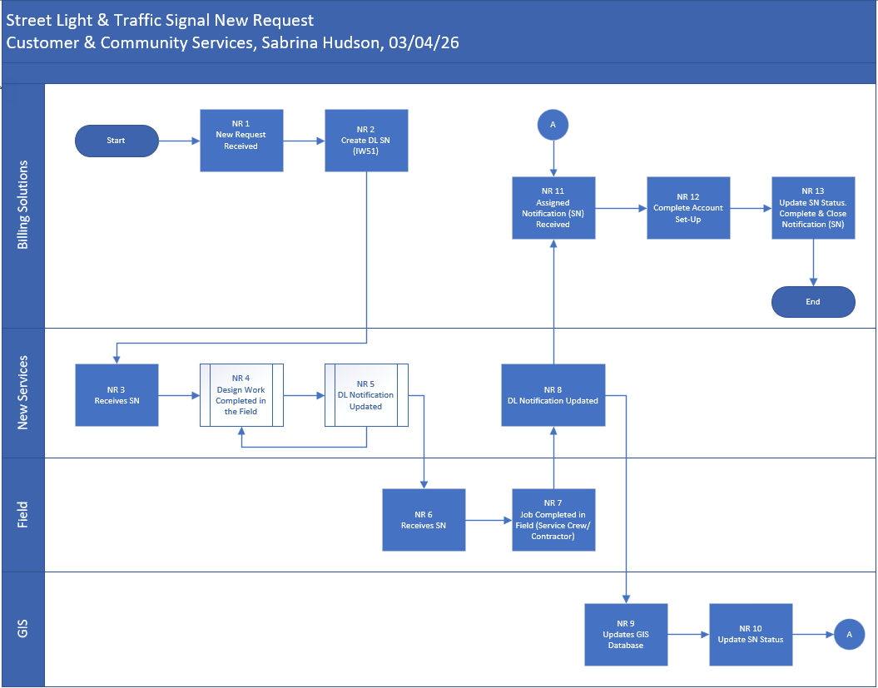

Task Description
Id | Task Description | Procedure
NR1 | New Request Received | - New requests are received via paper mail
NR2 | Create SN | - Access SAP transaction IW51  - Enter DL for notification and click enter  - Enter SL/TS rate category followed by the descriptive address and Service number provided by customer  - Click SN Status and check Need Inspection (NNAI) for metered service or Agency (NAIR) if inspection was included in new light request  - On Cust. Address tab, enter BP in Sold-To field  - Click the edit button to edit the address and use the descriptive address previously entered  - Click execute  - Click Yes to accept the address  - Click the Message address tab and click the edit button to edit the address, then click execute  - Click Yes to accept the address  - Enter type of work/serv provided in light request in the item section using dropdown menu  - Click the description editor button  - Copy and paste the SL/TS template into the SN and fill out all pertinent information  - Click the drop-down menu, then click create>create external document (URL) to attach light request and any included plans  - Copy/Paste URL link  - Click the drop-down menu, then click Attachment list, then double click the attachment to ensure it opens  - Click the Service Notification button>Print>Notification and enter Printer 510, then click Print/Fax  - Click the green flag  - Exit service notification
NR3 | Receive SN | - The service notification prints to New Services and is walked over to the Design group
NR4 | Design Work Completed in the Field | - Designer completes and approves the design for service and light placement  - Designer set the notification status to H4SR or H4IA for inspection or no inspection  - Designer sets the notification status to NFCC if rates 51, 52 & 57  - Designer sets the notification status to NFCU & NFWC if rate is rate 53 with line work  - Designer sets the notification status NCCD if rate 53 and no line work  - Note: there could be a back and forth between NR4 and NR5
NR5 | DL Notification Updated | - Dispatchers query SAP via SAP transaction IW59 for notifications with various statuses  - Notification status updated to NFCU & NFWW if rates 51, 52, 57  - Notification status updated to NFCU and NFWC if rate 53 and no line work
NR6 | Receives SN | - Notification is printed to Field Crew
NR7 | Job Completed in Field (Service Crew/Contractor) | - Field Crew works the notification  - Field Crew changes the notification status to NWSD in the Click application
NR8 | DL Notification Updated | - Dispatcher changes notification status to NFWC & NWAB in SAP to assign to Billing  - Dispatcher updates notification status to NFCU to assign to GIS  - Dispatcher updates notification status to NFWC if rate57
NR9 | Updates GIS Database | - GIS Tech updates GIS database
NR10 | Updates SN Status | - GIS updates status from NFCU to NFCC if rates 51, 52, 57, 53 with or without line work
NR11 | Assigned Notification Received | - Billing queries SAP for service notifications with NWAB status  - Billing sets notification status to NAIR for rate 51, 52, 57
NR12 | Complete Account Set-Up | - Billing completes Unmetered or Metered New Set process
NR13 | Update SN Status, Complete & Close Notification | - Billing changes notification status to NWCB and complete the notification

Business Rules
Id | Event Name | Business Rules
NR1 | New Request Received | - Only Public agencies can request and qualify for Street Light Rates  - Need Plans and actual street address to create SN  - Descriptive addresses are acceptable if the street name is an established address  - Rate 51 COM Street Light requests must be metered as of 1/1/2015  - Rate 53 DOM Street Lights are not metered and installed on existing SMUD poles  - Rate 53 DOM rate are for Public Agencies only – no longer allowed for HOA  - Rate 52 CODM rate was closed 1/1/2014, no new lights allowed on this rate  - All new DOM Street Light requests require a 15-year signed agreement before installment of lights (Except for the City & County of Sacramento)  - All DOM & CODM streetlights are unmetered  - All non-Public agency Street light requests will be a CITS-0 rate and does not come through Billing Solutions group Only

Event | Legal Requirements, Rules, and Regulations  Legal documents/ procedures/ requirements to be fulfilled before/at the specified event.
Id | Event | Legal Requirements, Rules and/or Regulations
N/A

Pain Points and Improvement Opportunities
- Billing creates a SN then prints the SN to Printer_510 which goes to the dispatchers. The dispatchers then hand walks the notification over to the Design group. If the notification was printed to Printer_521, the hand off could be eliminated
- When creating a DL notification (Type of Work/Type of Service) it would be nice if certain values like the type of work and type of service, and other elements were auto populated since the DL notification is specific to Streetlights, and would like specific pre-set values to be role-based (assigned for the Billing role)

Departments impacted by process change (Required)

Department | Type of Change(s) | Action Required
Billing
New Services
GIS

Supporting Documentation
(Any subsequent documentation in support of this business process (i.e. business requirements, technical specs, etc.) shall be summarized in the following table.)
Document Type | Link
Street Light New Request | Street Light_Traffic Signal New Request.vsdx
Street Light and Traffic Signal New Request process and procedure | SL & TS New Request
Street Light Database process and procedure | Street Light Database
Street Light Unmetered New Set process and procedure | SL Unmetered New Set
Street Light & Traffic Signal Month End Review process and procedure | SL & TS Month End Review
Street Light & Traffic Signal Metered New Set process and procedure | SL & TS Metered New Set
SL & TS Monthly Follow Ups process and procedure | SL & TS Monthly Follow Ups
1410 Street Light Balancing Report process and procedure | SL Balancing Report
1440 Street Light Discrepancy Report process and procedure | SL Discrepancy Report
SL TSF UFT Price Updates Blueprint | SL TSF UFT Price Updates

Business Blueprint Amendments

Any subsequent changes to this business process blueprint after the official document approval shall be summarized in the following table. This document must be reprinted and signed by the authorized representatives.
Version | Author | Description of Change | Approval (Name/Sign) | Date
v.0 | Sabrina Hudson | Initial Draft | Approved by Maya Duarte, 4/22/26 | 3/4/2026

